To Whom It May Concern:
On Friday, November 2, 2018, The Summer Hope Foundation will host the 16th Annual Summer Hope Benefit in support of our mission to provide the moments of HOPE to those who must endure the battle against cancer. We would like to invite you to support The Summer Hope Foundation by purchasing a contributing a sponsorship or journal advertisement or contributing a raffle or auction prize to the 16th Annual Summer Hope Benefit.
We are excited to announce a first at this year’s Summer Hope Benefit. For the first-time ever, we are pre-setting the goal for our annual Balloon Auction. Our goal? Well it’s our biggest ever: $30,000 in just a few minutes from a room full of passionate, loyal supporters. That $30,000 raised will be donated directly to the inaugural Kathy Stewart Memorial Scholarship Fund and The Michael Magro Foundation’s SOAR program, helping students reacclimate to school after their cancer diagnosis. These organizations, much like The Summer Hope Foundation honor loved ones who have battled cancer and were started in Hicksville, NY.
Your donation helps Summer Hope continue supporting cancer research facilities such as, the American Cancer Society and Memorial Sloan-Kettering Cancer Center. We are also able to help those directly affected by cancer. After 2016’s Summer Hope Benefit, we were able to not only continue our iPad Project, delivering iPads to the Pediatric Bone Marrow Transplant Unit of Cohen Children’s Hospital, but to name a room at Jamaica Hospital’s Hospice Unit, providing critical funds to help ensure that these patients will be able to see through their final days with dignity and grace. This is all because of support of our donors and we can’t thank you enough.
The Summer Hope Benefit is truly a magical night, and we hope that you choose to become a part of it.
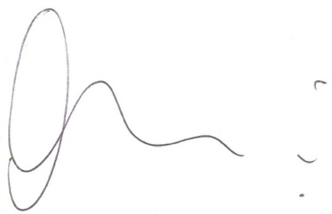
Yours In Hope

Edward Mouradian, Jr.
Founder & President,
The Summer Hope Foundation

